Stage 7 – Because you’d be in jail.
COURSE DESIGNER: Ike Starnes (modified from 2025 Race Gun Nationals)
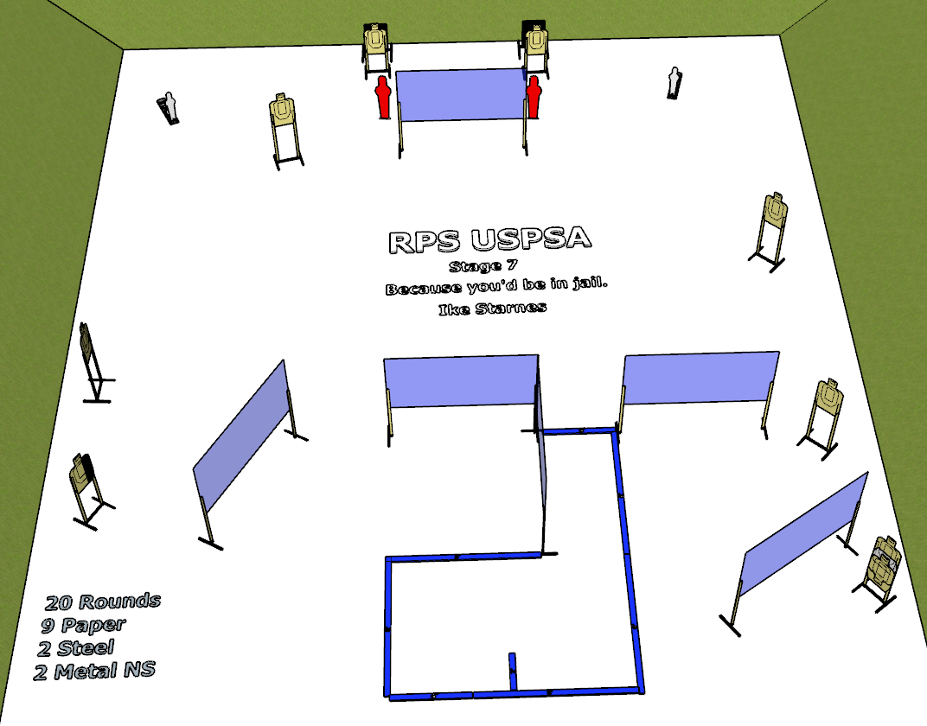

Written Stage Briefing:
Stage 7 – Because you’d be in jail. - is a 20 round, 100 point, Comstock course. There are 9 cardboard targets, 2 steel targets and 2 steel no-shoots. The best 2 hits per cardboard target will be scored.
Start position is straddling the start stick.
Handgun loaded and holstered, wrists below belt.
PCC loaded, stock on belt.

Setup Notes:
10 Single Wall Stands
5 Full Walls
8 Target stands / 16 target sticks
2 Mini Poppers and Bases
2 Large Poppers and Bases
RED PAINT


